Guest Guide

This is a guide for guests that are invited to use applications on MadeiraCloud. No MadeiraCloud account required.

Note: please refer our knowledge base to understand the app/stack concept

- Prerequisite
- Guest’s email address

- Invitation Email
The invitation is sent via email. An example is like below:
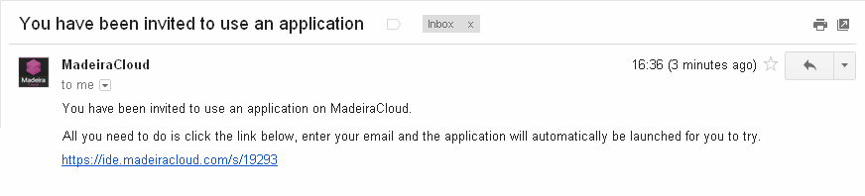
One email presents a single invitation. It can be used only once, and only by the one who is invited.
- Login
Click the URL in the email, a Guest IDE will open in your browser and type the email address that this invitation email is sent to to login:
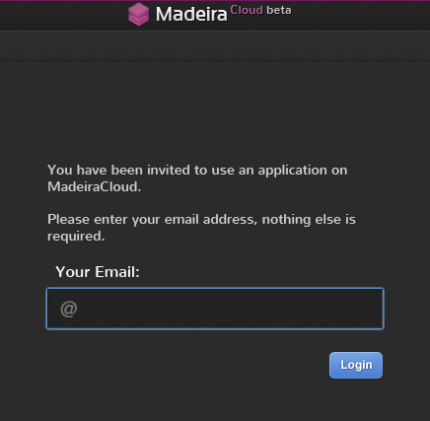

For the initial access, MadeiraCloud need to launch the guest app, please wait for a few moments:
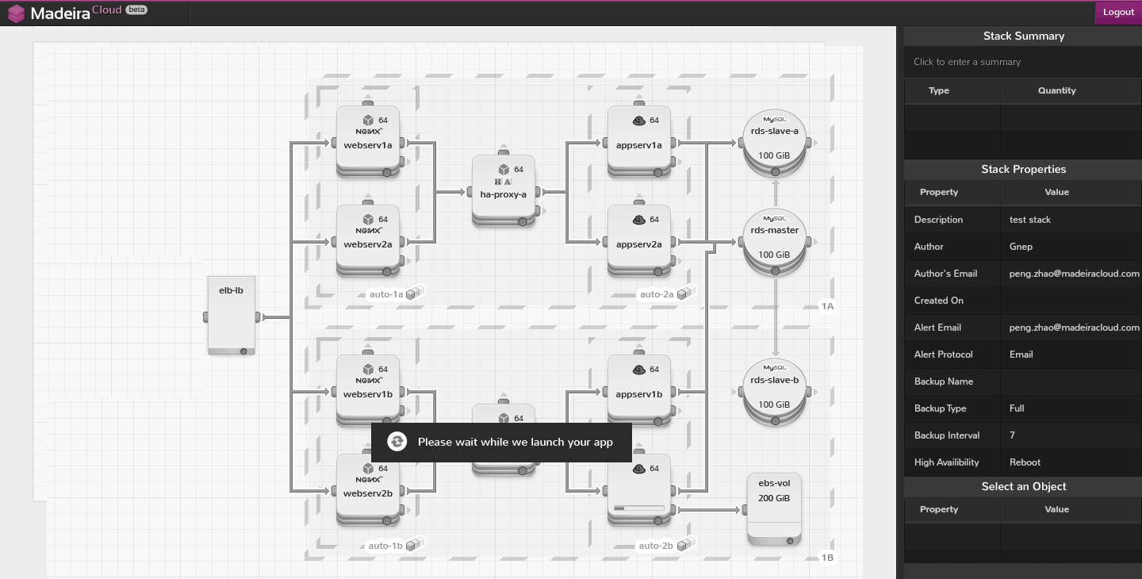
Done! Guest app is running now:
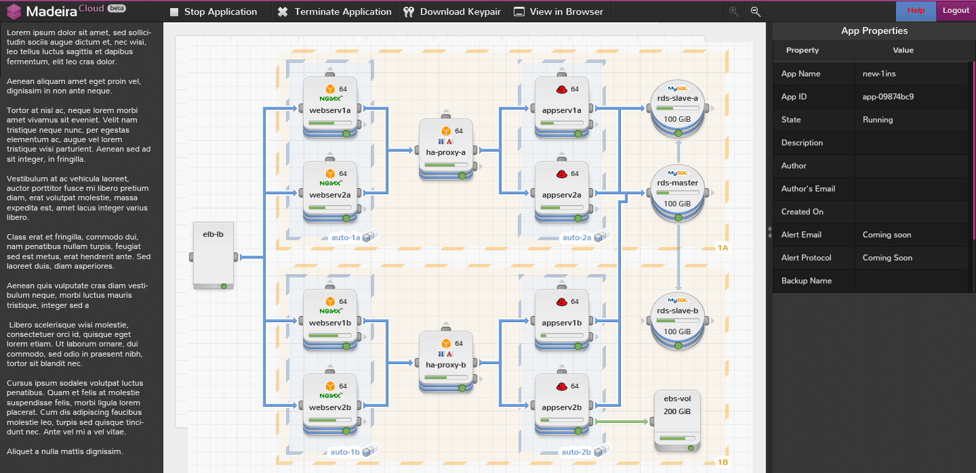

- Use the application
Click the keypair button to download the keypair (Note, every app has its own keypair, all instances in the app share this keypair)
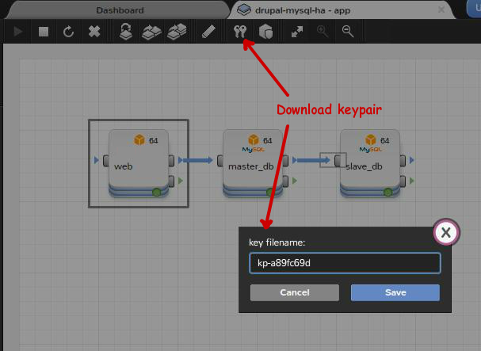

Get the instance’s public hostname
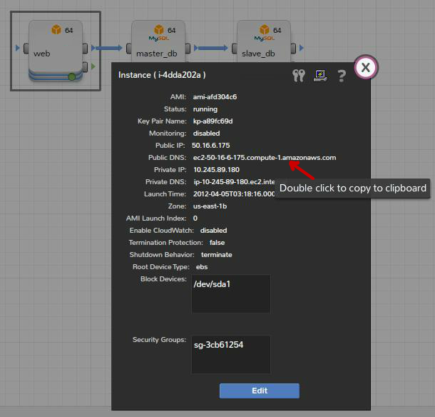

Then, use any SSH client to log into the instance.

Terminate the guest app once finished:

